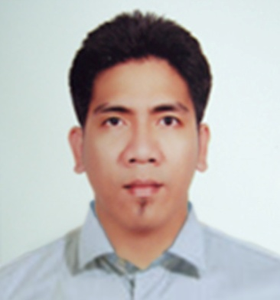
Pacholo U. Carmelotes
Current Address: Room 1601,Abu Haleeqa Bldg.
Leewa St., Abu Dhabi , U.A.E
Home Address: Blk.5 Bougainvilla St., Sitio San Jose, Daliao,Toril
Davao City , Philippines
E-mail Address : carmelotespacholo@gmail.com
carmelotespacholo@yahoo.com
On-line Portfolio :www.choyska.weebly.com
Birth Date : November 12,1979
Civil Status : Married
Age: 33 yrs.old
Height : 5' 8”
Sex : Male
Nationality : Filipino
Mobile No. : Abu Dhabi No. +971501747219
CAREER OBJECTIVE

Position requiring innovative, challenging , employment that utilize my education and professional skills and offer advance opportunity.
EUCATION

- 3rd year B.S Architecture, University of Mindanao-( 1997-2000)

- 2nd year Interior Design Student, Philippine Women’s College of Davao -( 2000-2002)
INTERNSHIP

- 3d Artist, CAD Operator, Draftsman ( H.R Magno Construction , Architectural Firm )
November 1998 – January 2002

- Prepare schematic drawings or sketches for new Architectural designs
- Make 2d drawings for plans and elevations
- Make the 2d drawing into 3d models for presentation
- Help manual renderings for presentation
- Help our engineer in billing cost of materials
- Site supervision

- 3d Artist , Designer, CAD Operator ( M.D.L Interior Designing Firm )
November 2002 – November 2003

- Prepare schematic drawings or sketches for new Interior design
- Make 2d drawings for plans and elevations
- Make the 2d drawing into 3d models for presentation
- Help manual renderings for presentation
- Site supervision
WORK EXPERIENCE

- Designer , CAD Technician, 3D Modeler, 3D Artist and Concept Artist ( Flower Boutique / Timeless Events , Abu Dhabi )
August 8, 2011 – Present

- Prepare schematic drawings or sketches for new Stage designs
- Cad Lay-out Preparation
- 3D Modeling , Texturing
- 3D Photorealistic Rendering for Presentation
- Responsible for the floor lay-out in venue
- Site supervision

- Senior CAD Technician, 3D Modeler, 3D Artist ( ALDAR Laing O’ Rourke Abu Dhabi, )
September 18, 2008 – July 18, 2009

- Working in Infrastructure as 4D Technician using SYNCHRO Software for presentation
- Setting-up the 3D Models in SYNCHRO for Program Management and Scheduling
- Splitting the 3D Models according to the Program of the Planning Team in the respective project
- Assist the Planning Engineers in Scheduling their Program in Gantt Chart in Synchro
- 3D Photorealistic Rendering for Presentation
- 3D modeling for all the Master Plan in the project
- Checking the clashes of all the Construction Design using Autodesk Navisworks Software
- Helping the Cad Technician in revising Construction Drawings
- Junior Coordinator for Utilities

- 3D Artist , CAD Operator ( Samuels Creation Dubai ,U.A.E )
September 2, 2007 – March 28, 2008

- Help in 3D modeling and 3D Photorealistic rendering for presentation
- Sketching rough design for proposal
- Detailing the design for Shop drawing
- Detailing Fixed and Loose Furniture
- Helping preparing B.O.Q

- 3D Artist , Draftsman, CAD Operator ( Greenline Yacht Interiors Dubai ,U.A.E )
April 25, 2006 – May 28, 2007

- Make in 3d Models and Photorealistic Rendering
- Help technical works and detailing wood works and joinery through drawings
- Responsible for the floor templates lay-out
- Helping for Detail Catalogue and shop drawings
- Furniture Detailing

- 3D Artist , Junior Design Coordinator -Furniture Company-( Maitland Smith Cebu Inc., MEPZ I, Gate II, Blk. IV, Ibo, Lapu - lapu City, Cebu, Philippines
June 2003 – March 2006

- Developed a new concept of designs
- Make in 3d Models and Rendering
- Coordinate my designs through technical works
- Detailing Fixed and Loose Furniture
- Market my designs
SKILLS and TALENT

- Knowledgeable in MS Word. Excel, PowerPoint
- Competent in Auto CAD
- Competent in 3d Studio Max with V-ray
- Knowledgeable in SYNCHRO
- Knowledgeable in Autodesk NavisWorks
- Knowledgeable in Z-brush and Maya
- Knowledgeable in Deep UV and Body Paint
- Knowledgeable in Photoshop
- Knowledgeable in Illustrator
- Knowledgeable in After Effects
- Knowledgeable in Autodesk Revit
- Proficient in Writing and Speaking
- Sketching, Sculpture and Painting, Song Writing

CERTIFICATE

- Completion of Training Program titled GREEN BUILDING & LEED CORE CONCEPTS
@ 3 Fold Education Centre , Abu Dhabi , U.A.E
- Completion of Training Program titled PROJECT MANAGEMENT ( APM-001)
@ 3 Fold Education Centre , Abu Dhabi , U.A.E
REFERENCE

- Mr. Francisco Abella
Senior Interior Designer / Senior Architect
Elite Design & Engineering Consultancy L.L.C
P.O Box 131489, Abu Dhabi ,U.A.E
Telephone No. +971 (0) 501 895697
Fax No. 02 5567309
Mobile No. +97150 1156428
E-mail Address: abellafrancisco@yahoo.com

- Mr. Nasir Kako
Senior Planning Manager
Mussafah Workforce Community
ALDAR Laing O’ Rourke Construction LLC
P.O Box 110800, Abu Dhabi ,U.A.E
Telephone No. 02 550 4110
Fax No. 02 550 4145
Mobile No. 0044 ( 0 ) 1405766151
E-mail Address: NKako@laingorourke.ae
nasir.kako@hotmail.com

- Mr. Stephen Dolan
Senior 4D CAD Consultant
SYNCHRO
Conventry University Technology Park, Swift Road, Conventry CV1 2TT
United Kingdom
Telephone No. +44 (0) 2476 792201
Mobile No. +44 ( 0 ) 7976 911695
E-mail Address: Stephen.dolan@synchroltd.com

DIALECT

English , Tagalog , Bisaya
ACHIEVEMENT

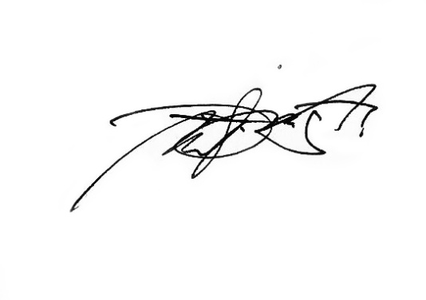
- 2003 3rd Prize Winner of National Painting Competition of Young Painters Annual
  - ( METROBANK Foundation )
- Young Painters Annual Member
  - ( METROBANK Foundation )

Pacholo U. Carmelotes
Applicant

